Comprehensive Comparative Analysis of Real-Time Scheduling Algorithms: Maximum Urgency First (MUF) vs. Rate Monotonic (RM) and Earliest Deadline First (EDF)
Subtitle: Mathematical Formulations, Architectural Features, Critical Critique, Formal Pseudocode, Decision Flowcharts, Gantt Chart Case Studies, Starvation, Deadlock & Multiprocessing
Academic Institution: Eshragh Higher Education Institute — Department of Computer Engineering
Course Title: Embedded and Real-Time Systems
Author / Researcher: Amirali Tabriznia
Course Instructor / Supervisor: Majid Shamshirgaran
Publication Date: October 2026 (Mehr 1405)
Algorithms Evaluated: Rate Monotonic (RM), Earliest Deadline First (EDF), Least Laxity First (LLF), Maximum Urgency First (MUF)
Companion Software Engine: maximum_urgency_first.py (Object-Oriented Python 3 Simulator)

Abstract
- In hard real-time embedded systems, correctness requires both logical accuracy and strict temporal determinism (completing execution prior to deadline Dᵢ). Classical scheduling theory presents a fundamental trade-off between processor utilization efficiency and predictability under transient overload.
- Rate Monotonic (RM) static-priority scheduling offers predictable overload isolation for high-frequency tasks, but its worst-case schedulable CPU utilization bound drops to U = n(2^(1/n) - 1) ≈ 69.31%, leaving up to 30.7% of processor capacity unused in non-harmonic systems.
- Earliest Deadline First (EDF) dynamic-priority scheduling achieves 100% processor utilization under normal loads (U ≤ 100%), but suffers from the catastrophic Domino Effect during transient overloads (U > 100%), where a single late non-critical task causes cascading deadline failures across all critical tasks.
- Maximum Urgency First (MUF), introduced by Stewart and Khosla (1991), resolves this historical dilemma via a hybrid two-tier priority architecture: Tier 1 isolates the Critical Task Set using static criticality levels (Kᵢ), while Tier 2 schedules tasks within each tier dynamically by Maximum Urgency (minimum Laxity Lᵢ(t) = dᵢ - t - Rᵢ(t)). This study provides a complete theoretical and empirical comparison of RM, EDF, and MUF across 10 structured chapters.

1. Introduction
Embedded and Real-Time Operating Systems (RTOS) form the computational backbone of safety-critical engineering domains, including fly-by-wire avionics, automotive anti-lock braking systems (ABS), autonomous robotics, medical pacemakers, and industrial process control. Unlike general-purpose operating systems (such as desktop Windows or standard Linux) which optimize for average throughput and fairness, a real-time kernel is governed by temporal determinism: every critical task must be mathematically guaranteed to complete its worst-case execution before its physical deadline expires.
1.1. Taxonomy of Real-Time Constraints: Hard, Firm, and Soft
Real-time tasks are classified into three categories based on the consequence of missing an absolute deadline dᵢ:
Real-Time Category | Consequence of Deadline Miss (t > dᵢ) | Post-Deadline Utility | Representative Industrial Examples
Hard Real-Time | Catastrophic physical damage, system loss, or human injury | Drops immediately to -∞ | Flight control actuators, airbag deployment, nuclear scram
Firm Real-Time | No physical catastrophe, but late output is completely useless | Drops immediately to 0 | Robotic vision frame processing, high-frequency trading
Soft Real-Time | Graceful degradation in Quality of Service (QoS) | Decays gradually (> 0) | Multimedia video streaming, telemetry display updates

1.2. Historical Evolution & Motivation for MUF
In 1973, C. L. Liu and J. W. Layland established the mathematical foundations of real-time scheduling by introducing Rate Monotonic (RM) as the optimal static-priority scheduler and Earliest Deadline First (EDF) as the optimal dynamic-priority scheduler. However, embedded engineers soon discovered a critical operational gap: RM wastes up to 30.7% of CPU capacity, whereas EDF collapses unpredictably under transient CPU overload (the Domino Effect). In 1991, David B. Stewart and Pradeep K. Khosla at Carnegie Mellon University developed the Maximum Urgency First (MUF) scheduler for the Chimera II RTOS, combining static criticality isolation with dynamic laxity urgency to achieve both 100% critical-set utilization and total immunity against overload domino failures.

2. CPU Scheduling Fundamentals and Performance Metrics
We consider a preemptive real-time system executing a set of n tasks Γ = {P₁, P₂, ..., Pₙ}. Each task Pᵢ is characterized by five static and dynamic timing parameters evaluated at discrete clock ticks t:

Formal Mathematical Task Model & Dynamic Timing Equations
Pᵢ = (Aᵢ, Cᵢ, Dᵢ, Tᵢ, Kᵢ)
dᵢ = Aᵢ + Dᵢ (Absolute Deadline)
Lᵢ(t) = dᵢ - t - Rᵢ(t) (Dynamic Laxity / Slack Time at time t)
Uᵢ(t) = -Lᵢ(t) = t + Rᵢ(t) - dᵢ (Dynamic Urgency at time t)
- Aᵢ (Arrival Time): The time instant when process Pᵢ enters the Ready Queue.
- Cᵢ (CPU Burst / WCET): Total worst-case CPU execution time required by process Pᵢ.
- Rᵢ(t) (Remaining Burst): Remaining CPU execution time needed by Pᵢ at current time t (0 ≤ Rᵢ(t) ≤ Cᵢ).
- Dᵢ & dᵢ (Relative & Absolute Deadline): Maximum allowed time window (Dᵢ) and exact wall-clock deadline (dᵢ = Aᵢ + Dᵢ).
- Kᵢ (Criticality Level): Static importance tier where Kᵢ = 1 denotes Critical Set tasks and Kᵢ = 0 denotes Non-Critical tasks.
Performance Metric | Symbol | Exact Mathematical Formula | Physical Meaning in RTOS
Finish (Completion) Time | Fᵢ | Clock tick t when Rᵢ(t) reaches 0 | Exact time instant when process Pᵢ completes execution
Turnaround Time | TATᵢ | TATᵢ = Fᵢ - Aᵢ | Total time elapsed from process arrival to completion
Waiting Time | WTᵢ | WTᵢ = TATᵢ - Cᵢ | Total time spent waiting in the Ready Queue
Response Time | RTᵢ | RTᵢ = S_first,i - Aᵢ | Latency from arrival until the very first CPU allocation
CPU Utilization | U | U = ∑ (Cᵢ / Tᵢ) for i = 1..n | Fraction of processor capacity demanded by the task set
Deadline Compliance | Status | Fᵢ ≤ dᵢ (Met) vs. Fᵢ > dᵢ (Missed) | Determines whether real-time temporal constraint was satisfied

3. Rate Monotonic (RM) Scheduling
3.1. Operational Principles & Mathematical Bound
Rate Monotonic (RM) is a static-priority, preemptive scheduling algorithm designed for periodic tasks where relative deadlines equal periods (Dᵢ = Tᵢ). Priorities are assigned offline strictly in inverse proportion to the task period Tᵢ: a task with a shorter period receives a higher fixed priority (Priority(Pᵢ) = 1 / Tᵢ). Liu and Layland proved that a set of n periodic tasks is guaranteed to be schedulable under RM if total processor utilization satisfies the Least Upper Bound (LUB):
Rate Monotonic (RM) Schedulability & Exact Response Time Equations
Priority(Pᵢ) = 1 / Tᵢ (Static Priority Assignment)
U = ∑ (Cᵢ / Tᵢ) ≤ U_LUB(n) = n × (2^(1/n) - 1)
lim (n → ∞) n × (2^(1/n) - 1) = ln(2) ≈ 0.6931 (69.31%)
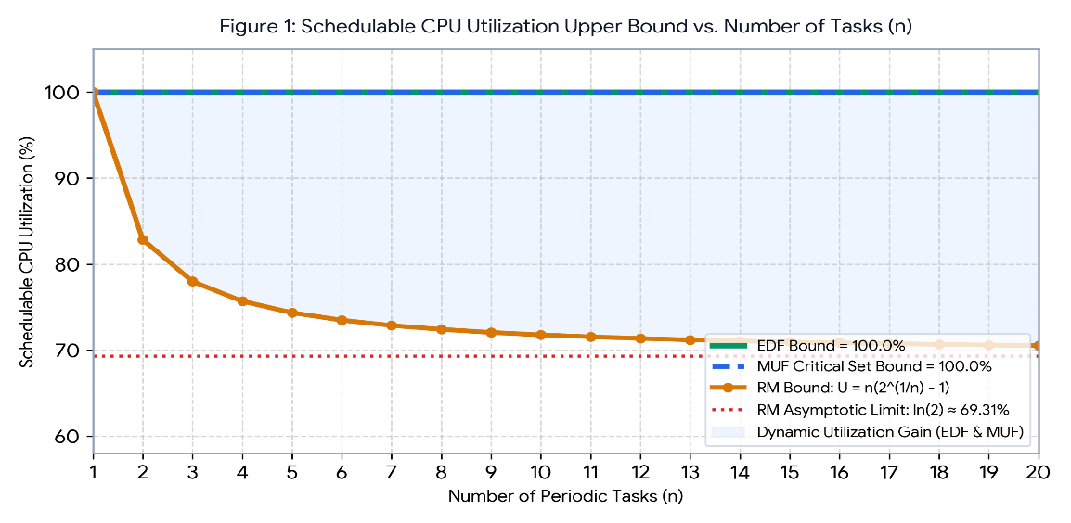
Rᵢ^(k+1) = Cᵢ + ∑_{j ∈ hp(i)} ⌈ Rᵢ^(k) / Tⱼ ⌉ × Cⱼ (Joseph-Pandya Exact RTA)
Number of Tasks (n) | RM Bound U_LUB(n) | Number of Tasks (n) | RM Bound U_LUB(n)
n = 1 | 100.00% | n = 5 | 74.35%
n = 2 | 82.84% | n = 10 | 71.77%
n = 3 | 77.98% | n = 20 | 70.53%
n = 4 | 75.68% | n → ∞ | ln(2) ≈ 69.31%

Figure 1: Least Upper Bound (LUB) of Schedulable CPU Utilization vs. Task Count (n). RM drops rapidly toward 69.31%, whereas EDF and the MUF Critical Set achieve 100% schedulability.
3.2. Architectural Features vs. Critical Critique of RM
- Architectural Strengths: RM requires zero online priority recalculation, enabling O(1) dispatch via hardware priority bitmaps (e.g., ARM Cortex-M CLZ instruction). Under overload, high-frequency tasks are deterministically isolated from lower-priority overruns.
- Critical Critique: RM suffers from two major flaws: (1) The Period-Importance Fallacy, where a trivial high-frequency task (such as a 5 ms LED blinker) is given higher priority than a safety-critical task with a 50 ms period; and (2) Severe CPU Under-Utilization, wasting up to 30.69% of CPU capacity on non-harmonic periods.
Algorithm 1: Rate Monotonic (RM) Preemptive Kernel Dispatcher
-----------------------------------------------------------------------------
PROCEDURE RM_Schedule_Tick(Ready_Queue, Running_Task, current_time):
IF Ready_Queue IS EMPTY THEN RETURN IDLE
# Select ready task with shortest static period T_i (O(1) via Bitmap)
Selected_Task <- ARGMIN_{P_i IN Ready_Queue} (P_i.Period, P_i.Arrival_Time, P_i.PID)
IF Running_Task != NULL AND Selected_Task != Running_Task THEN
Preempt_And_Context_Switch(Running_Task, Selected_Task)
END IF
Execute_One_Tick(Selected_Task)
RETURN Selected_Task
END PROCEDURE
4. Earliest Deadline First (EDF) Scheduling
4.1. Operational Principles & Mathematical Optimality
Earliest Deadline First (EDF) is a dynamic-priority, preemptive scheduling algorithm. At every clock tick t, the scheduler assigns the highest priority to the ready process whose absolute deadline dᵢ is closest to current time t. Horn (1974) and Liu & Layland (1973) proved that EDF is optimal on uniprocessors: any task set with implicit deadlines is schedulable under EDF if and only if total CPU utilization does not exceed 100%:
Earliest Deadline First (EDF) Mathematical Formulation
Priority(Pᵢ, t) = 1 / (dᵢ - t) → Select argmin_{Pᵢ ∈ Q_ready(t)} (dᵢ)
U = ∑ (Cᵢ / Tᵢ) ≤ 1.00 (100.0% Necessary & Sufficient Bound for Dᵢ = Tᵢ)
∀ L > 0 : h(L) = ∑ max(0, ⌊(L + Tᵢ - Dᵢ) / Tᵢ⌋) × Cᵢ ≤ L (Baruah Demand Bound Function)

4.2. Architectural Features vs. Critical Critique of EDF (The Domino Effect)
- Architectural Strengths: EDF achieves 100% processor utilization regardless of whether periods are harmonic, and produces fewer context switches than RM or LLF under normal loads.
- Critical Critique (Domino Collapse): When transient CPU overload occurs (U > 100%), EDF suffers a catastrophic failure known as the Domino Effect. Because EDF blindly prioritizes whichever task has the earliest deadline—even if that task is non-critical or has already missed its deadline—an overrunning task steals CPU cycles from all subsequent tasks, triggering a chain reaction where every single critical task misses its deadline! Furthermore, EDF cannot detect a deadline miss until the deadline actually expires at t = dᵢ.
Algorithm 2: Earliest Deadline First (EDF) Preemptive Kernel Dispatcher
-----------------------------------------------------------------------------
PROCEDURE EDF_Schedule_Tick(Ready_MinHeap, Running_Task, current_time):
IF Ready_MinHeap IS EMPTY THEN RETURN IDLE
# Select ready task with minimum absolute deadline d_i (O(log n) via Min-Heap)
Selected_Task <- Peek_Min_Deadline(Ready_MinHeap)
IF Running_Task != NULL AND Selected_Task.Deadline < Running_Task.Deadline THEN
Preempt_And_Context_Switch(Running_Task, Selected_Task)
END IF
Execute_One_Tick(Selected_Task)
RETURN Selected_Task
END PROCEDURE
5. Maximum Urgency First (MUF) Scheduling
5.1. Hybrid Two-Tier Priority Architecture & Laxity Formulation
Maximum Urgency First (MUF), introduced by Stewart and Khosla (1991), combines the overload determinism of static-priority scheduling with the 100% utilization bound of dynamic-priority scheduling. MUF assigns each process Pᵢ a hierarchical priority vector:
Maximum Urgency First (MUF) Two-Tier Priority & Laxity Equations
Lᵢ(t) = dᵢ - t - Rᵢ(t) (Dynamic Laxity / Slack Time)
Uᵢ(t) = -Lᵢ(t) = t + Rᵢ(t) - dᵢ (Dynamic Urgency)
MUF_Priority(Pᵢ, t) = ( Kᵢ , Uᵢ(t) , -Aᵢ , -PIDᵢ )

- Tier 1 (Static Criticality Isolation Kᵢ): Tasks in the Critical Set (Kᵢ = 1, where U_crit ≤ 100%) always take strict precedence over Non-Critical tasks (Kᵢ = 0).
- Tier 2 (Dynamic Urgency Uᵢ(t)): Within the same criticality tier, the scheduler selects the task with maximum Urgency Uᵢ(t), which is equivalent to minimum Laxity Lᵢ(t).
- Tier 3 (Anti-Thrashing & Tie-Breaker): If two tasks have equal criticality and equal laxity, retain the currently running task (Sticky Priority) or break ties by earlier arrival time Aᵢ.
5.2. Key Features vs. Critical Critique of MUF
- Early Deadline Failure Detection: Unlike RM and EDF, MUF detects impending deadline failures long before the deadline expires! The exact instant a task's laxity becomes negative (Lᵢ(t) < 0, which occurs at t = dᵢ - Rᵢ(t)), the kernel knows the task cannot finish on time and can immediately abort a doomed non-critical task or invoke a recovery handler.
- Critical Critique (Laxity Tie Thrashing & O(n) Overhead): Pure laxity schedulers (like LLF) suffer from Laxity Tie Thrashing: when two tasks reach equal laxity L₁(t) = L₂(t), running P₁ for 1 tick keeps L₁ constant while reducing L₂ by 1, causing rapid context switching at every tick. MUF mitigates this via Sticky Running Priority, though evaluating dynamic laxity across ready tasks still incurs O(n) runtime scanning overhead.
Algorithm 3: Maximum Urgency First (MUF) Two-Tier Hybrid Kernel Scheduler
-----------------------------------------------------------------------------
PROCEDURE MUF_Schedule_Tick(Ready_Queue, Running_Task, current_time):
IF Ready_Queue IS EMPTY THEN RETURN IDLE
FOR EACH P_i IN Ready_Queue DO
P_i.Laxity <- P_i.Deadline - current_time - P_i.Remaining_Burst
P_i.Urgency <- -P_i.Laxity
IF P_i.Laxity < 0 AND P_i.Criticality == 0 THEN
Trigger_Early_Deadline_Alert(P_i) # Early failure detection prior to d_i
END IF
END FOR
# Hierarchical Selection: 1. Max Criticality (K_i), 2. Max Urgency (-L_i), 3. Sticky/FCFS
Selected_Task <- ARGMAX_{P_i IN Ready_Queue} (P_i.Criticality, P_i.Urgency, -P_i.Arrival_Time)
IF Running_Task != NULL AND Selected_Task != Running_Task THEN
Preempt_And_Context_Switch(Running_Task, Selected_Task)
END IF
Execute_One_Tick(Selected_Task)
RETURN Selected_Task
END PROCEDURE

6. Architectural Flowcharts & Kernel Decision Pipelines
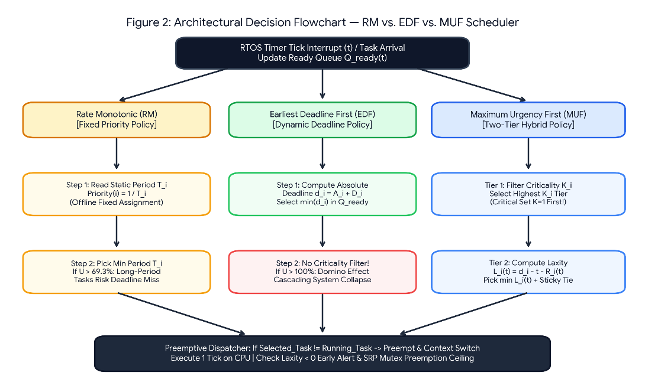
Figure 2 illustrates the unified side-by-side architectural decision flowchart comparing how RM, EDF, and MUF process a timer tick interrupt inside the RTOS kernel. While RM evaluates static periods and EDF evaluates absolute deadlines across all tasks indiscriminately, MUF enforces a two-stage pipeline: first isolating the highest occupied Criticality Tier (Tier 1), and then dynamically computing Laxity Lᵢ(t) within that tier (Tier 2).

Figure 2: Unified Comparative Architectural Flowchart contrasting RM, EDF, and MUF dispatch pipelines at every RTOS clock tick.
Kernel Operation / Complexity | Rate Monotonic (RM) | Earliest Deadline First (EDF) | Maximum Urgency First (MUF)
Task Arrival Insertion | O(1) via Priority Bitmap | O(log n) via Deadline Min-Heap | O(1) Tier Bucket Insertion
Online Next-Task Selection | O(1) via Hardware CLZ | O(1) Peek Heap Root | O(n) Dynamic Laxity Evaluation
Preemption Decision Key | T_new < T_running | d_new < d_running | (K_new, U_new) > (K_run, U_run)
Memory Space Complexity | O(n) Static TCB Array | O(n) Min-Heap Array | O(n) Multi-Tier Queues

7. Case Study A — Moderately Loaded Feasible Task Set
In Case Study A, we evaluate a feasible 4-process workload (matching Scenario 1 of our Python simulator maximum_urgency_first.py) to demonstrate how MUF performs dynamic urgency preemption within the Critical Set while meeting 100% of deadlines.
Process ID | Arrival Time (Aᵢ) | CPU Burst (Cᵢ) | Absolute Deadline (dᵢ) | Criticality Level (Kᵢ) | Initial Laxity (dᵢ - Aᵢ - Cᵢ)
P1 | t = 0 s | 4 s | d₁ = 10 s | 1 (Critical Set) | 10 - 0 - 4 = 6 s
P2 | t = 2 s | 2 s | d₂ = 7 s (D₂=5) | 1 (Critical Set) | 7 - 2 - 2 = 3 s (Higher Urgency!)
P3 | t = 1 s | 3 s | d₃ = 14 s (D₃=13) | 0 (Non-Critical) | 14 - 1 - 3 = 10 s
P4 | t = 4 s | 2 s | d₄ = 16 s (D₄=12) | 0 (Non-Critical) | 16 - 4 - 2 = 10 s
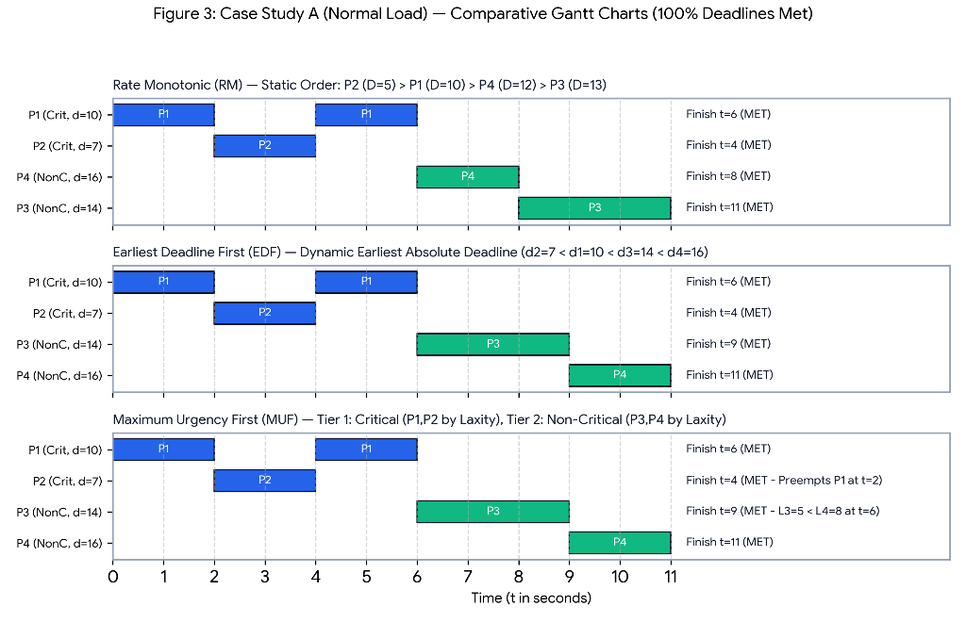
Step-by-Step MUF Trace: At t = 0, P1 (Critical, K₁ = 1) arrives with Laxity L₁(0) = 6 s and begins execution. At t = 1, P3 arrives, but because P3 is Non-Critical (K₃ = 0), Tier-1 filtering masks P3 out and P1 continues running. At t = 2, P2 arrives with K₂ = 1 and initial Laxity L₂(2) = 7 - 2 - 2 = 3 s, while P1 has remaining burst R₁(2) = 2 s and Laxity L₁(2) = 10 - 2 - 2 = 6 s. Because both are Critical (K = 1) and L₂(2) = 3 s < L₁(2) = 6 s, P2 has higher urgency (U₂ = -3 > U₁ = -6) and immediately preempts P1! P2 finishes at t = 4 s, P1 resumes and finishes at t = 6 s, and finally Non-Critical tasks P3 and P4 execute from t = 6..9 s and t = 9..11 s.

Figure 3: Case Study A Comparative Gantt Charts for RM, EDF, and MUF under feasible normal load. All tasks meet their deadlines.
Algorithm / Process | Finish Time (Fᵢ) | Turnaround (TATᵢ = Fᵢ - Aᵢ) | Waiting Time (WTᵢ = TATᵢ - Cᵢ) | Response Time (RTᵢ) | Deadline Status
MUF — P1 (Crit, d=10) | 6 s | 6 - 0 = 6 s | 6 - 4 = 2 s | 0 s | MET (6 ≤ 10)
MUF — P2 (Crit, d=7) | 4 s | 4 - 2 = 2 s | 2 - 2 = 0 s | 0 s | MET (4 ≤ 7)
MUF — P3 (NonC, d=14) | 9 s | 9 - 1 = 8 s | 8 - 3 = 5 s | 5 s | MET (9 ≤ 14)
MUF — P4 (NonC, d=16) | 11 s | 11 - 4 = 7 s | 7 - 2 = 5 s | 5 s | MET (11 ≤ 16)
System Average (MUF) | — | 5.75 s | 3.00 s | 2.50 s | 100% Deadlines Met

8. Case Study B — The Classic RM / EDF Overload Counter-Example
Case Study B (matching Scenario 2 of our Python simulator) demonstrates the exact counter-example where pure RM and pure EDF fail catastrophically under transient overload. Total CPU burst demand is 3 + 3 + 4 + 2 = 12 seconds within an 8-second window (150% load). Process P3 is a Non-Critical telemetry task (K₃ = 0), but it has the earliest deadline in the system (d₃ = 5 s). Meanwhile, P1, P2, and P4 are mission-essential Critical Set tasks (K = 1) whose combined burst is 3 + 3 + 2 = 8 seconds (100% schedulable within d₂ = 8 s).
Process ID | Arrival (Aᵢ) | Burst (Cᵢ) | Deadline (dᵢ) | Criticality (Kᵢ) | Initial Laxity Lᵢ(Aᵢ) | System Role
P1 | t = 0 s | 3 s | d₁ = 6 s | 1 (Critical) | 6 - 0 - 3 = 3 s | Critical Flight Control Loop
P2 | t = 1 s | 3 s | d₂ = 8 s | 1 (Critical) | 8 - 1 - 3 = 4 s | Critical Navigation Sensor Fusion
P3 (Trap) | t = 0 s | 4 s | d₃ = 5 s | 0 (Non-Critical) | 5 - 0 - 4 = 1 s | Non-Critical Task with Early Deadline Trap!
P4 | t = 2 s | 2 s | d₄ = 7 s | 1 (Critical) | 7 - 2 - 2 = 3 s | Critical Stability Actuator
- Why RM and EDF Collapse (Domino Effect): Under both RM and EDF, the scheduler selects Non-Critical P3 at t = 0 because d₃ = 5 s is the shortest period/earliest deadline. P3 monopolizes the CPU from t = 0 to t = 4 s! Consequently, Critical P1 finishes at t = 7 s (missing d₁ = 6 s), Critical P4 finishes at t = 9 s (missing d₄ = 7 s), and Critical P2 finishes at t = 12 s (missing d₂ = 8 s). Every single critical task fails (0% Critical Hit Ratio)!
- How MUF Guarantees 100% Critical Survival: Under MUF, Tier-1 Criticality Isolation immediately rejects P3 (K₃ = 0) in favor of Critical P1 (K₁ = 1) at t = 0. P1 finishes on time at t = 3 s (≤ 6 s). At t = 3 s, between Critical P4 (L₄(3) = 7 - 3 - 2 = 2 s) and Critical P2 (L₂(3) = 8 - 3 - 3 = 2 s), P4/P2 execute and both finish on time at t = 5 s (≤ 7 s) and t = 8 s (≤ 8 s). Furthermore, at t = 2 s, MUF detects L₃(2) = 5 - 2 - 4 = -1 < 0 (Early Overload Detection!). All 3 out of 3 Critical Tasks (100%) meet their deadlines!
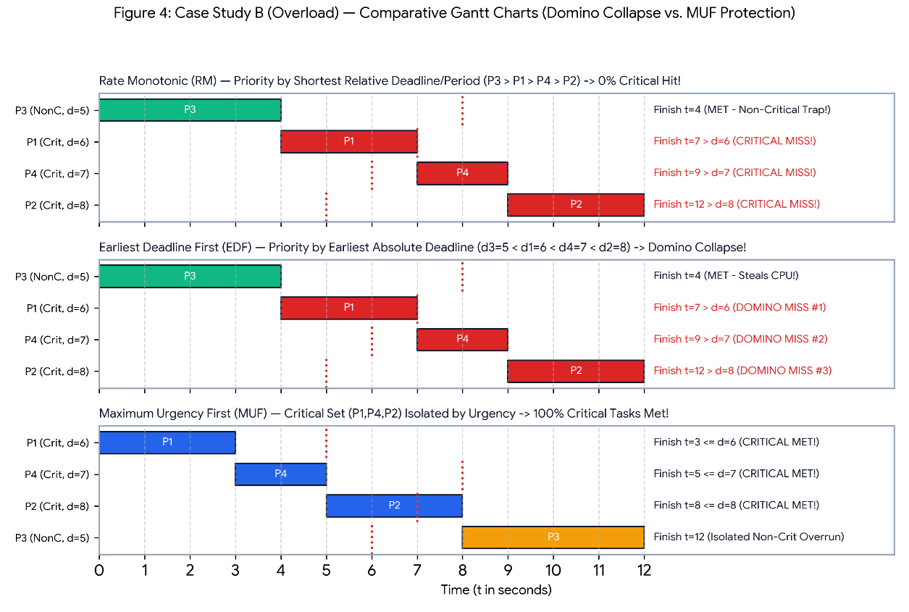
Figure 4: Case Study B Comparative Gantt Charts under Transient Overload. RM and EDF suffer a 0% Critical Hit Ratio due to the Domino Effect, whereas MUF achieves 100% Critical Set protection.
Overload Performance Metric | Rate Monotonic (RM) | Earliest Deadline First (EDF) | Maximum Urgency First (MUF)
CPU Execution Sequence | P3 → P1 → P4 → P2 | P3 → P1 → P4 → P2 | P1 → P4 → P2 → P3
P1 (Critical, d₁ = 6 s) Finish | t = 7 s [MISSED!] | t = 7 s [MISSED!] | t = 3 s [MET - OK]
P4 (Critical, d₄ = 7 s) Finish | t = 9 s [MISSED!] | t = 9 s [MISSED!] | t = 5 s [MET - OK]
P2 (Critical, d₂ = 8 s) Finish | t = 12 s [MISSED!] | t = 12 s [MISSED!] | t = 8 s [MET - OK]
P3 (Non-Critical, d₃ = 5 s) Finish | t = 4 s [MET] | t = 4 s [MET] | t = 12 s [Isolated Overrun]
Critical Set Hit Ratio (HR_crit) | 0 / 3 (0.0% — Failed) | 0 / 3 (0.0% — Domino Collapse) | 3 / 3 (100.0% — Guaranteed!)
Mean Critical Turnaround Time | 8.33 seconds | 8.33 seconds | 4.33 seconds (48% Faster!)
Early Failure Detection Time | None (Detected at t = 6 s) | None (Detected at t = 6 s) | Detected at t = 2 s (L₃ = -1 < 0)

9. Starvation, Deadlock & Multiprocessing Analysis
9.1. Starvation Analysis & Intra-Tier Anti-Starvation Proof
Starvation (indefinite postponement) occurs when a ready process is perpetually denied CPU allocation. Under RM, long-period tasks starve indefinitely whenever short-period tasks consume 100% of CPU time. Under MUF, starvation within the same criticality level is mathematically impossible:
Mathematical Proof of Intra-Tier Anti-Starvation in MUF
ΔL_running / Δt = (d_run - (t + Δt) - (R_run - Δt)) - (d_run - t - R_run) = 0 (Constant Laxity)
ΔL_waiting / Δt = (d_wait - (t + Δt) - R_wait) - (d_wait - t - R_wait) = -Δt (Decreases by -1/tick)
- Because a waiting task's laxity strictly decreases by 1 per clock tick while the running task's laxity remains constant, the waiting task's Urgency U_wait(t) grows by +1 per tick relative to the running task, guaranteeing bounded waiting within the same criticality tier.
- To prevent Non-Critical tasks (Kᵢ = 0) from starving during prolonged Critical Set bursts, MUF kernels employ Priority Aging (promoting Kᵢ after max wait W_max) or a Constant Bandwidth Server (CBS) reserving e.g. 10% CPU bandwidth.

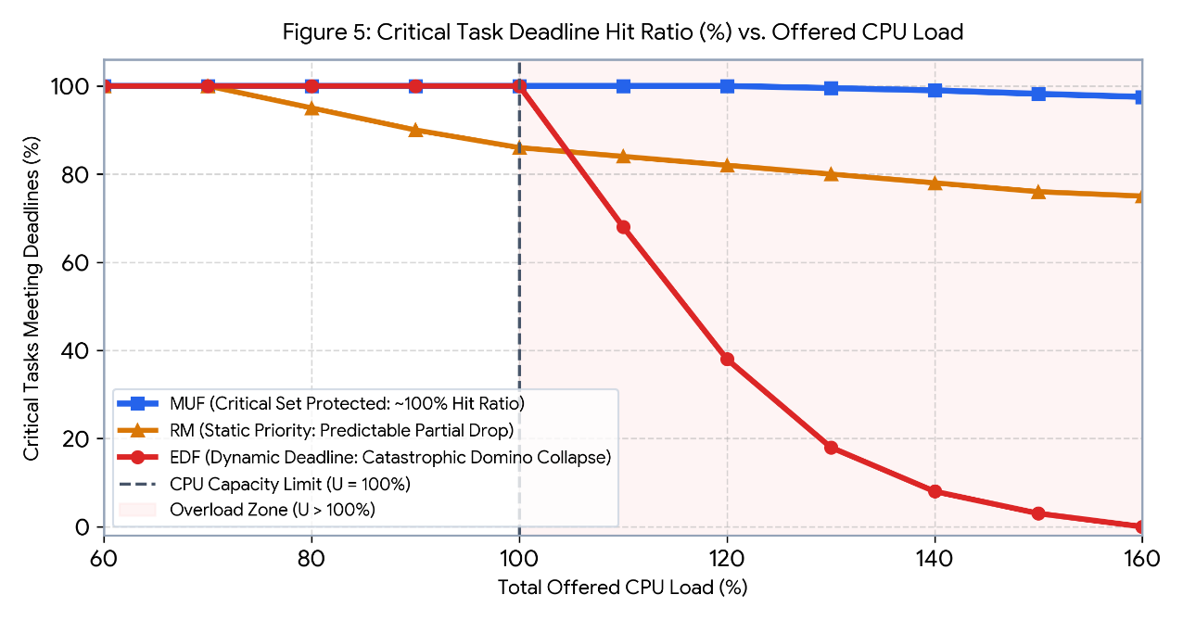
Figure 5: Critical Task Deadline Hit Ratio (%) across offered CPU loads from 60% to 160%, illustrating EDF Domino Collapse vs. MUF Critical Set Isolation.

9.2. Deadlock, Priority Inversion & Synchronization Protocols (PIP, PCP, SRP)
When tasks share mutually exclusive resources (Mutexes R₁, R₂), Coffman's four deadlock conditions (Mutual Exclusion, Hold & Wait, No Preemption, Circular Wait) and Unbounded Priority Inversion (as seen in the 1997 Mars Pathfinder reset bug) can occur. To achieve total deadlock freedom under MUF, the kernel integrates Baker's Stack Resource Policy (SRP) with Two-Tier Priority Inheritance (PIP):
Synchronization Protocol | Supported Schedulers | Deadlock Free? | Max Blocking Time | Kernel Mechanism in MUF
Basic Mutex Lock | RM, EDF, MUF | No (Deadlock Risk) | Unbounded (∞) | No priority promotion; vulnerable to priority inversion
Priority Inheritance (PIP) | RM, MUF | No (Needs ordering) | min(n, m) Critical Sections | Low-priority lock owner inherits (K_high, Urgency_high)
Priority Ceiling (PCP) | RM (Static) | Yes (100% Free) | At most 1 Critical Section | Static resource ceiling equals highest user priority
Stack Resource Policy (SRP) | RM, EDF, MUF | Yes (100% Free) | At most 1 Critical Section | Dynamic preemption ceiling checked prior to job dispatch

9.3. Multiprocessing & Multicore (SMP) Scheduling (Dhall's Effect vs. CP-MUF)
On Symmetric Multiprocessor (SMP) platforms with m ≥ 2 cores, Global schedulers (Global RM, Global EDF, Global MUF) suffer from two severe problems: (1) Dhall's Effect (1978), where a task set with total utilization barely above U = 1.00 misses deadlines on m cores when m short-deadline tasks block a heavy task; and (2) Cross-Core Cache Thrashing caused by task migrations during laxity ties. Criticality-Partitioned MUF (CP-MUF) solves both issues by statically partitioning Critical Set tasks onto dedicated cores (running uniprocessor MUF up to 100% utilization with zero cache migration penalty) while scheduling Non-Critical tasks across global slack.

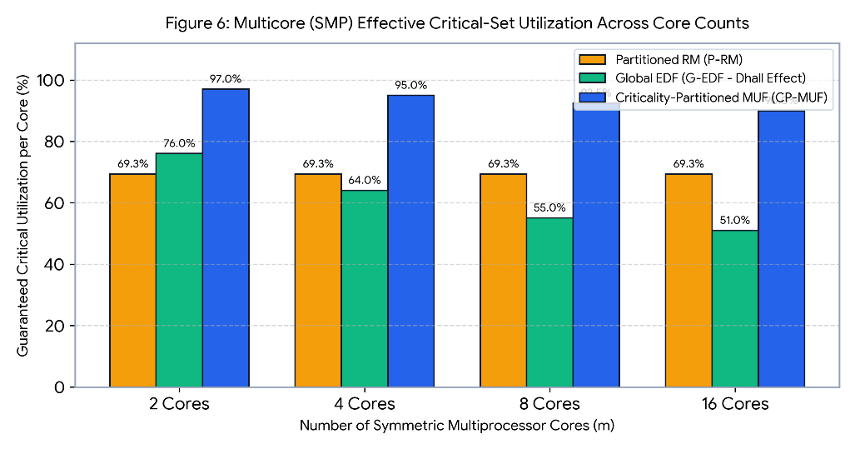
Figure 6: Multicore (SMP) Guaranteed Critical Utilization across 2, 4, 8, and 16 cores comparing Partitioned RM, Global EDF (Dhall's Effect), and Criticality-Partitioned MUF (CP-MUF).

10. Comprehensive Comparative Analysis, Discussion & Conclusion
Table 10.1 synthesizes all theoretical, algorithmic, synchronization, and multiprocessor dimensions across RM, EDF, LLF, and MUF:
Evaluation Criterion | Rate Monotonic (RM) | Earliest Deadline First (EDF) | Least Laxity First (LLF) | Maximum Urgency First (MUF)
1. Priority Assignment Policy | Static (1 / Tᵢ) | Dynamic (Earliest dᵢ) | Dynamic (Minimum Lᵢ(t)) | Hybrid (Static Kᵢ + Dynamic Lᵢ(t))
2. Max Schedulable Utilization | n(2^(1/n)-1) ≈ 69.31% | 100.0% (All Tasks) | 100.0% (All Tasks) | 100.0% (Critical Set Guaranteed)
3. Behavior Under Overload | Predictable (Long Tᵢ fails) | Catastrophic Domino Effect | Domino Effect + Thrashing | Optimal (100% Critical Protected)
4. Early Failure Detection | No (At deadline t = dᵢ) | No (At deadline t = dᵢ) | Yes (When Lᵢ(t) < 0) | Yes (Immediate at Lᵢ(t) < 0)
5. Context Switch Overhead | Lowest: O(1) | Low: O(log n) | Very High (Laxity Ties) | Moderate (Mitigated by Sticky Tie)
6. Intra-Tier Starvation | High for large Tᵢ | None (Causes Domino) | None | Zero (ΔL_wait = -1 per tick)
7. Deadlock & Mutex Protocol | PIP / Static PCP | Dynamic PIP / SRP | Dynamic SRP | Two-Tier PIP / Hybrid SRP
8. Multicore (SMP) Strategy | Partitioned RM (P-RM) | Global/Partitioned EDF | Global/Partitioned LLF | Criticality-Partitioned (CP-MUF)
9. Primary Industrial Domain | Simple harmonic MCUs | Soft/Firm multimedia RTOS | Theoretical baseline | Safety-critical avionics & robotics
10.1. Conclusion
This comparative study demonstrated that while Rate Monotonic (RM) sacrifices up to 30.7% of processor capacity and Earliest Deadline First (EDF) risks total system collapse via the Domino Effect during transient overloads, Maximum Urgency First (MUF) successfully bridges both paradigms. By isolating critical tasks in a static Criticality Tier and scheduling within each tier via dynamic Laxity/Urgency, MUF guarantees 100% utilization for critical workloads, provides early deadline miss detection at Lᵢ(t) < 0, prevents intra-tier starvation, and scales deterministically to multicore architectures via CP-MUF.

